Hugging Face Transformers

A 04: Hugging face Transformers

Learning Outcome

Tools / Software Requirements
Python (>= 3.7), IDE: PyCharm (preferred) or VSCode

Contents
- Objectives
- Core Ideas
- Hugging face
- Transformer Library
- Tasks
- Additional Resources

Core Ideas

- Hugging Face Transformers is a high-level library that simplifies the use of pretrained Transformer models for NLP tasks like text classification, sentiment analysis, and question answering.
- Auto Tokenizer automatically converts raw text into numerical input (tokens) that the model can process.
- AutoModelForSequenceClassification lets us load pretrained architectures for classification tasks without manually defining layers.
- The datasets library provides quick access to popular datasets such as IMDb, AG News, and GLUE benchmarks.
- Trainer API abstracts away the manual training loop — handling training, evaluation, and metrics automatically.

- Evaluation Metrics (accuracy, precision, recall, F1-score) provide insights into model performance and behavior.
The lab emphasizes practical application of these components to fine-tune a model and interpret its performance.

Hugging face
Hugging Face has cultivated one of the most vibrant AI communities in the world, with users contributing new AI models, datasets, tutorials and research daily. They offer a rich API that allows developers to integrate models directly into applications, and their platform supports a wide range of tasks across many use cases and industries. Here are some of the platform’s main advantages:
- Access to the latest models
- Simplified workflows
- Simple deployment and scaling
- Thriving community
- Focus on responsible AI
Before starting the lab, it is a good idea to go through the fundamentals of hugging face explained
below that will give you a kick start for the today’s tasks.

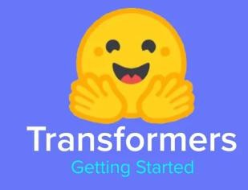

Transformer Library
Hugging Face Transformers is an open-source Python library that provides access to thousands of pre-trained Transformers models for natural language processing (NLP), computer vision, audio tasks, and more. Hugging Face provides access to models (both the code that implements them and their pre-trained weights), model-specific tokenizers, as well as pipelines for common NLP tasks, and datasets and metrics in a separate `datasets` package. It has implementations in PyTorch, Tensorflow, and Flax (though we'll be using the PyTorch versions here!)

Pipelines
Pipelines are high-level, ready-to-use interfaces for performing common tasks with pre-trained models. They provide an easy-to-use API through pipeline () method for performing inference over a variety of tasks. They are used to encapsulate the overall process of every Natural Language Processing task, such as text cleaning, tokenization, embedding, etc.
The pipeline () method has the following structure:
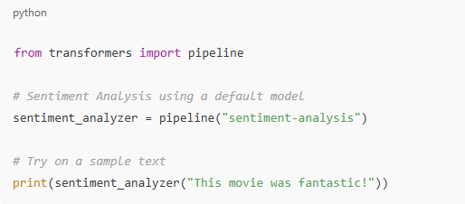
Pipelines automatically handle tokenization, model loading, and decoding — perfect for testing and understanding model behavior before fine-tuning.

Tokenizers

Before a model can understand text, it must be converted into numerical format. This is handled by a Tokenizer, which splits the text into tokens and maps them to IDs in the model's vocabulary.
Transformers can’t read text directly — they need numbers. The Tokenizer handles:
- Splitting text into smaller units (tokens)
- Mapping them to numerical IDs
- Adding special tokens ([CLS], [SEP])
- Ensuring sequences have equal length (padding/truncation)
An example snippet of code to use the tokenizer from the transformer library in hugging face is:-

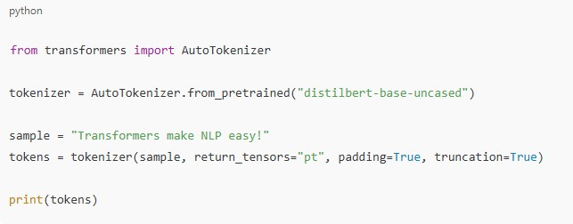
Auto Tokenizer automatically selects the right tokenizer for the given model.

:- Models
Initializing models is very similar to initializing tokenizers. You can either use the model class specific to your model or you can use an AutoModel class. I tend to prefer AutoModel, especially when I want to compare models, because it's easy to specify the models as strings.
While most of the pretrained transformers have similar architecture, if you there are additional weights, called "heads" that you have to train if you're doing sequence classification, question answering, or some other task.
- Hugging Face automatically sets up the architecture you need when you specify the model class. For example, we are doing sentiment analysis, so we are going to use DistilBertForSequenceClassification.
- If we were going to continue training DistilBERT on its masked-language modeling training objective, we would use DistilBertForMaskedLM.
- and if we just wanted the model's representations, maybe for our own downstream task, we could just use DistilBertModel.
A full list of choices are available in the docs. Note that not all models are compatible with all model architectures, for example DistilBERT is not compatible with the Seq2Seq models because it only consists of an encoder.

:- Loading Pretrained Models
Hugging Face allows you to load pretrained models with one line of code using the
AutoModelForSequenceClassification or similar classes depending on the task. from transformers import AutoModelForSequenceClassification

model = AutoModelForSequenceClassification.from_pretrained("siebert/sentiment-roberta- large-english")
The model is ready for inference or fine-tuning. You don't need to define layers manually —
architecture is auto-configured.

:- Datasets
Instead of writing custom DataLoader classes, Hugging Face provides a high-level interface through the datasets library. Some of the commonly used functions in the lab are:
- load_dataset(): Quickly loads benchmark datasets like IMDb, SST2, GLUE, etc.
- .map(): Applies preprocessing (like tokenization) to the entire dataset efficiently.
- .train_test_split(): Splits data for training and evaluation
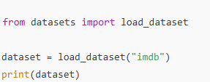

:- The Trainer API
Rather than manually coding training loops as typically done in PyTorch, Hugging Face simplifies the process by providing the Trainer class. This high-level API handles essential tasks such as model training and evaluation, manages logging and checkpointing during the training process, and automates the computation of performance metrics, thereby streamlining the entire model fine-tuning workflow.

Functions:-
- TrainingArguments: Configuration (batch size, epochs, etc.)
- Trainer: Wraps the model, tokenizer, and dataset
- compute_metrics: Function used to evaluate accuracy or F1-score

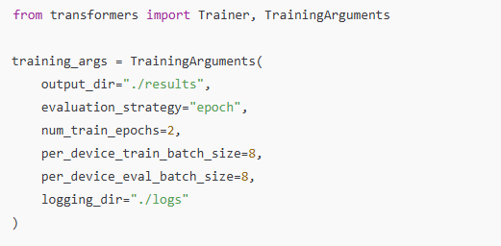
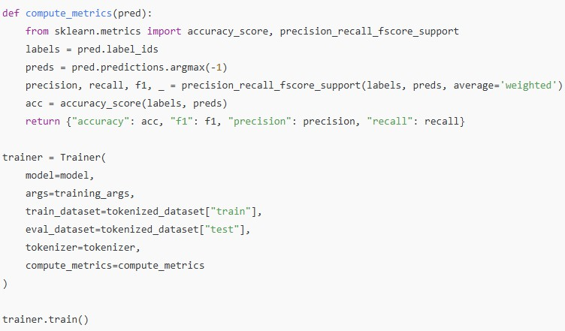

Since now you are familiar with the basic functions to be used in the lab, the tasks for today re listed below for you.

Tasks
Fine-Tune a Simple Transformer Model for Text Classification

Objective:
Fine-tune a simple Transformer-based model (e.g., BERT, DistilBERT, or RoBERTa) for a text classification task.

Instructions:
- Load dataset: Choose a classification dataset (e.g., IMDb for sentiment analysis, AG News for topic classification).
- Tokenization: Tokenize text using AutoTokenizer, ensuring proper padding and truncation.
- Load pretrained model: Use AutoModelForSequenceClassification and fine- tune it on the dataset.
- Train model: Use the Hugging Face Trainer API for training with appropriate hyperparameters
- Evaluation: Measure accuracy, precision, recall, and F1-score.
- Analysis: Compare predictions before and after fine-tuning, and discuss key observations.

Bonus Task: Try different Transformer models, optimize training with early stopping, or visualize attention scores.
Note:- For the details of the tasks and basic structure of the code, please refer to the attached notebook.

Additional Resources
- https://huggingface.co/docs/tokenizers/en/quicktour
- https://huggingface.co/course
- https://www.voiceflow.com/blog/hugging-face-tutorial
- https://365datascience.com/trending/what-is-hugging-face/
- https://www.oreilly.com/library/view/natural-language-processing/9781098103231

